***Customer Support Robo Chart***

*When user visit the website, we provide a chart service with our customer care to user like user can ask the questions regarding our website and what service we are providing without exploring the complete website, page to page, by asking to our customer or robot their can know much more about our website*

*Texting, chatting and online messaging can be used for much more than simply communicating with your friends. Online communication can help any project to build and develop a trust and friendness with clinets and can attract them*

*Providing real time customer service via messaging to the website or mobile app visitors. Online chat empowers businesses to handle customer queries efficiently and forge happier customer relationships*

*Live chat helps with customer acquisition and onboarding*

## *Live chat lets your agents build rapport with customers*

## *Live chat reduces repetition for your customers*

## *Live chat boosts your customer service team’s productivity*

## *Live chat lets you provide 24/7 support*

## *Live chat increases customer engagement*

## *Live chat data helps inform product decisions*

## *Achieving support success with live chat*

## *Live chat can give you an edge over your competition*

*1. Livechatinc :  
Livechatinc is a website which which provide the service of charting for any website , where client can chart with customer*

*The is the official page of the website as show in the photo*

*the url :* [*https://my.livechatinc.com/chats/RB0E2CFMA4/RB0E2CFMB4*](https://my.livechatinc.com/chats/RB0E2CFMA4/RB0E2CFMB4)

*1st we need to create a account and login then the user interface will look like these*

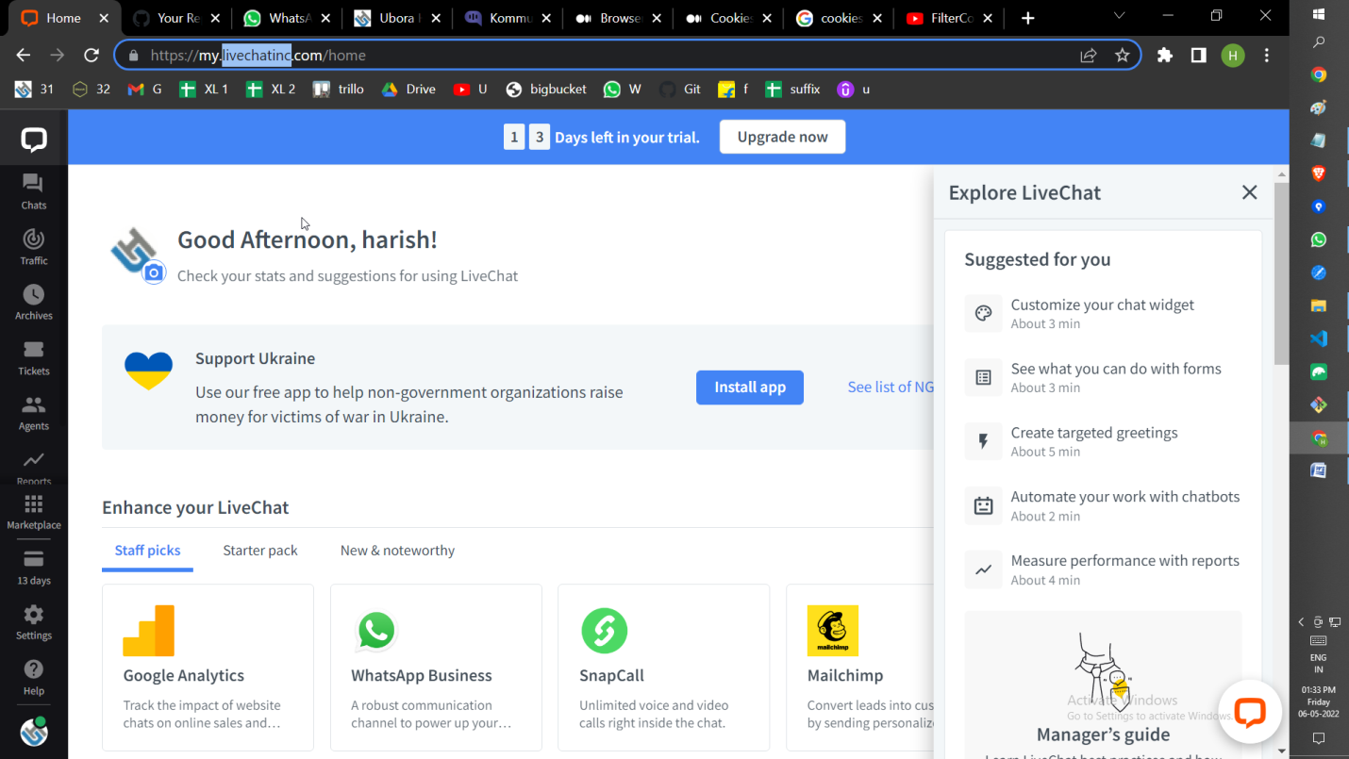

*Copy the script*

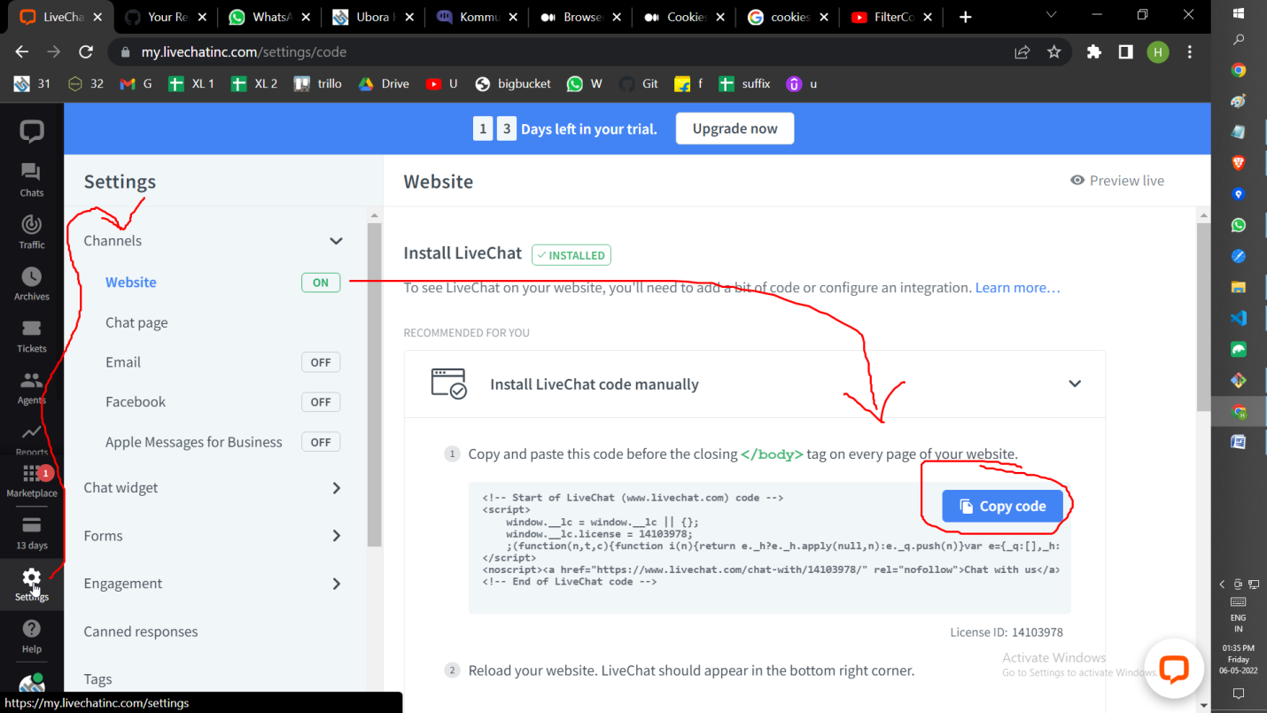

*As show in the photo , copy the script tag*

*Into the clipboard*

*Pasted in the index.html  
  
As show in the below images  
  
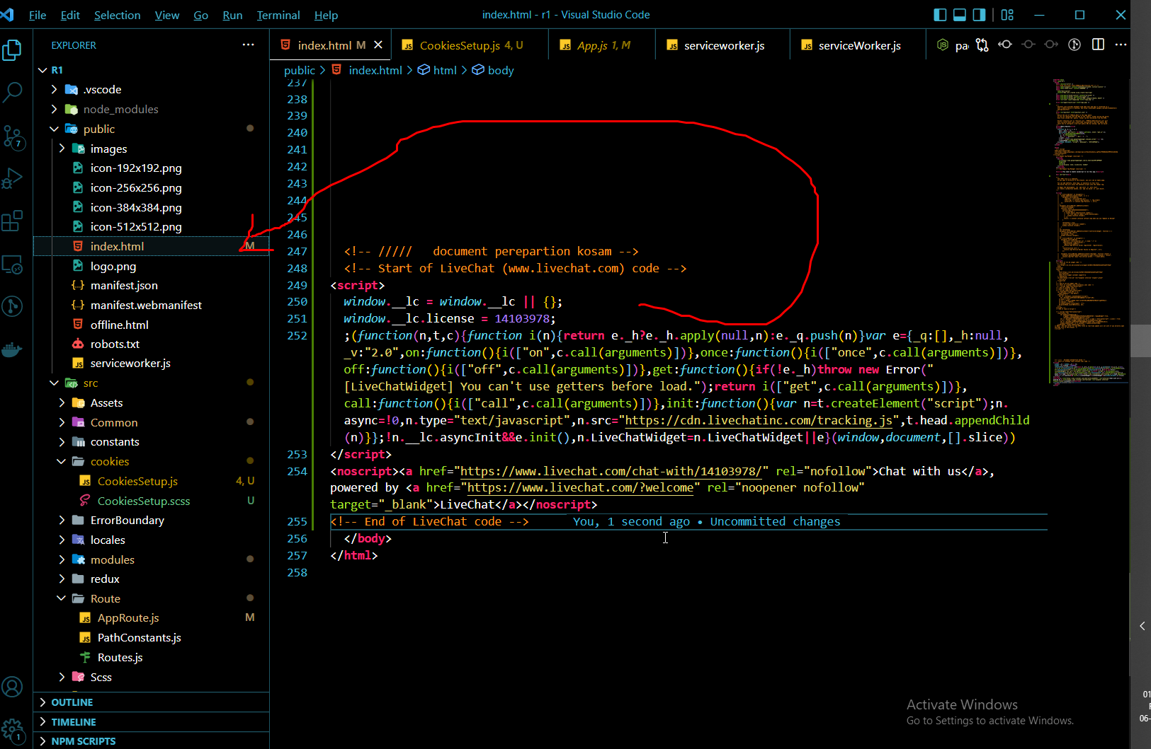*

*Output*

*After passing it when we open our project, we will get these kind of the icon in at bootom right corner of our website  
As shown in the webpage  
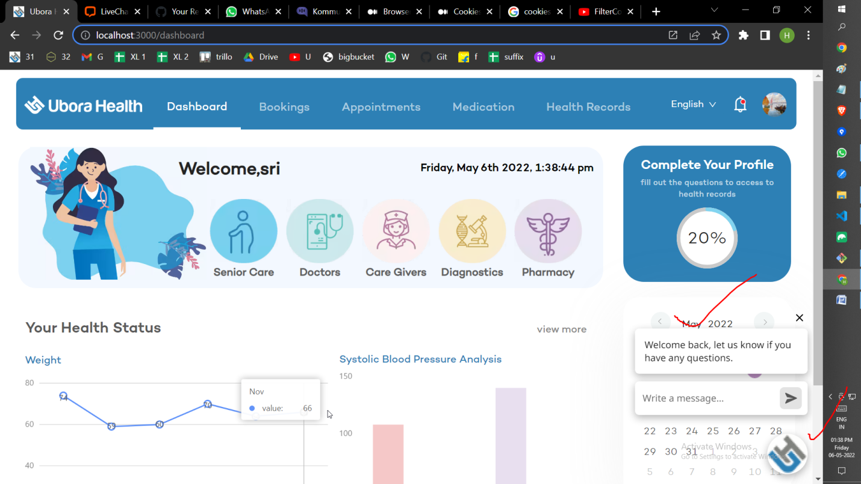  
when we click or open that icon we will get a popup like these as shown in the images  
on enter all the required details then we can start the charting, for example I typed the www and press the enter, instantly will get a message 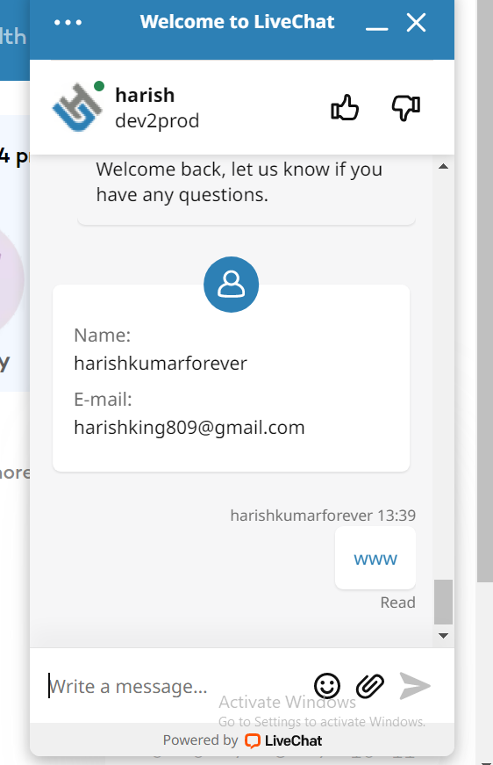e in in the Livechatinc website, we can see it as show in the below photo*

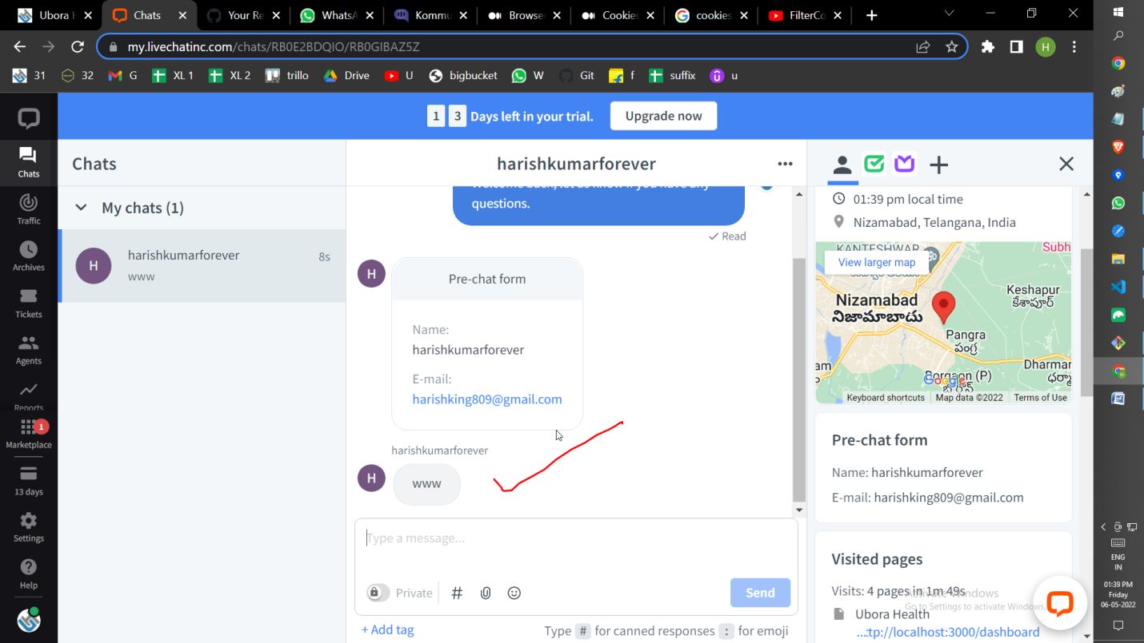

*And if i reply for that message, then the client will receive the message as show in the below photo*

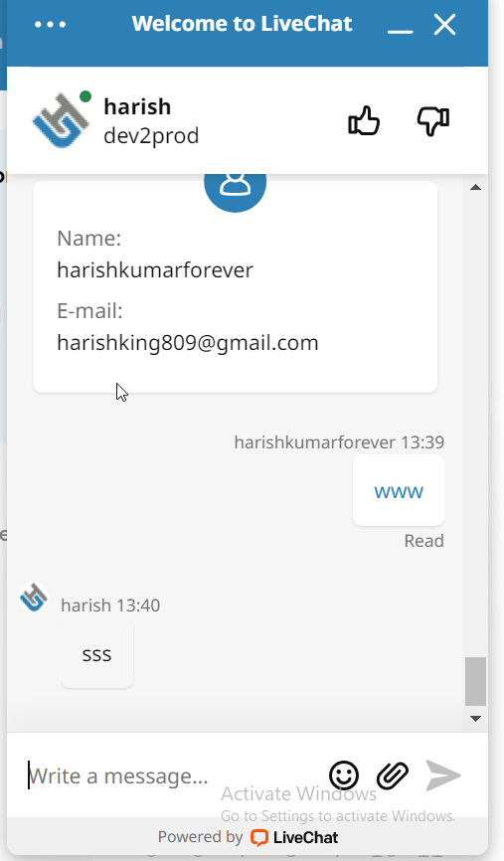

*In these way we can establish a connection between the user and customer*

*And I have explore reaming website also which provide these kind same charting system,*

*But im not going to explain all these here,   
all of them work same as these Livechatinc website,   
so explore by yourself  
im providing the url of some of the website*

*Remaining all the website also provide same features****1.https://dashboard.tawk.to/#/chat***

***2.*** [***https://app.txt.me/#/home-page***](https://app.txt.me/#/home-page) ***3.https://dashboard.kommunicate.io/conversations/72193642***

***Robo charting***

*Kommunicate website: is the website which provide a robo charting , 1st try to create a account and login the account then u will find these user interface   
  
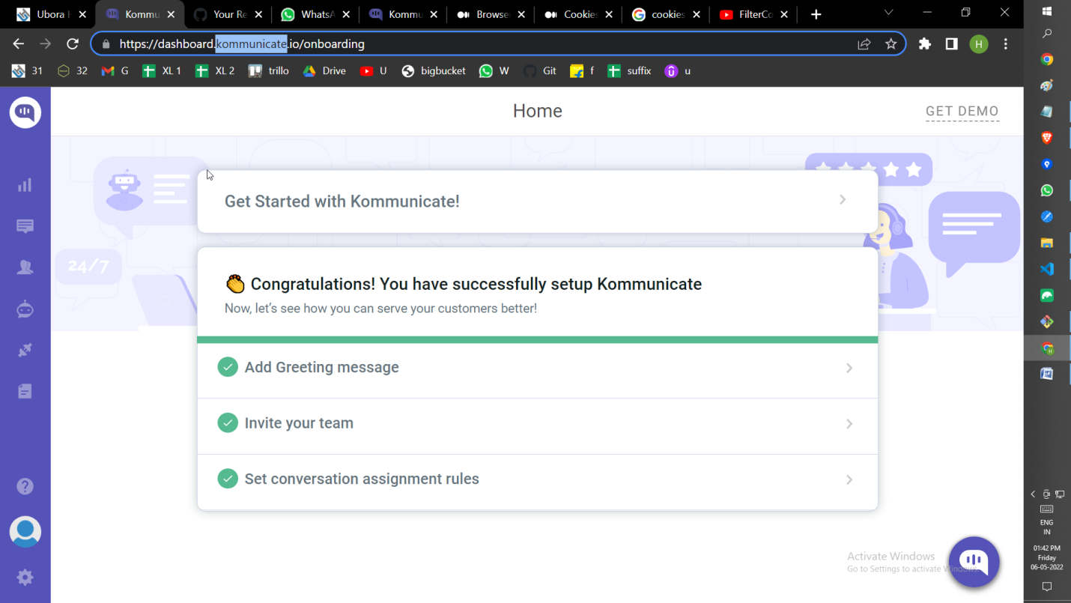  
then go the Bot integration tab then form there select the bot biuilder option then select theboat which u created*

*As show in the photo*

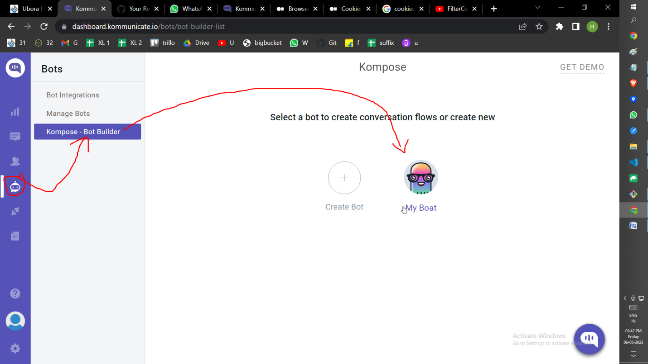

*On clicking these you will open a UI like these*

*Here u can make all the customization what u want for example for our user app we have doctor and caregiver and diagnosis and senior module, I create a button as show in the photo,*

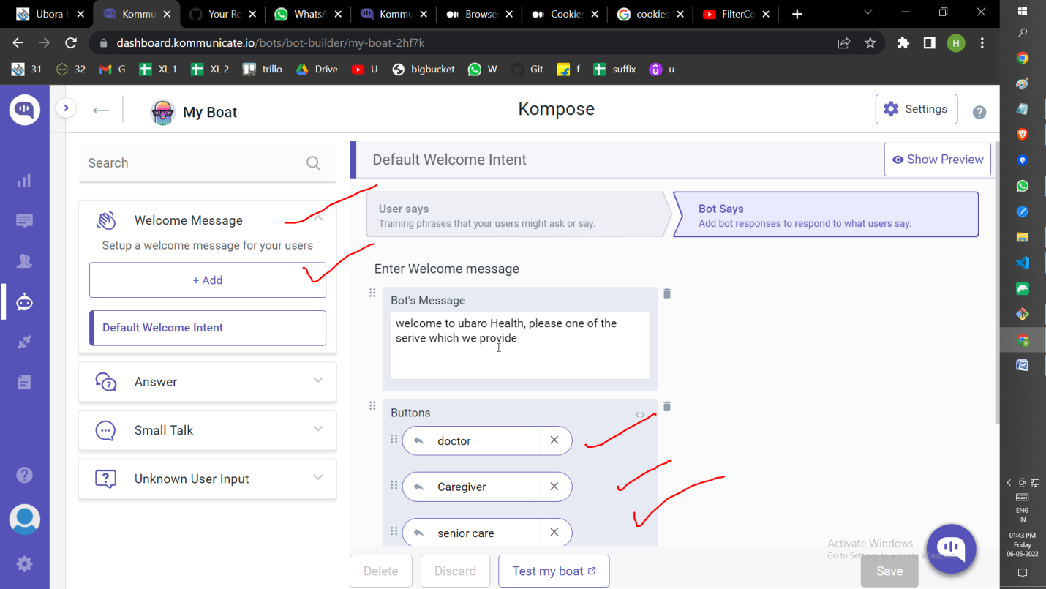

*Then I linked these buton with the some text , don’t worry when u will edit these tab u will get all the options their, u can easily edit it and config it*

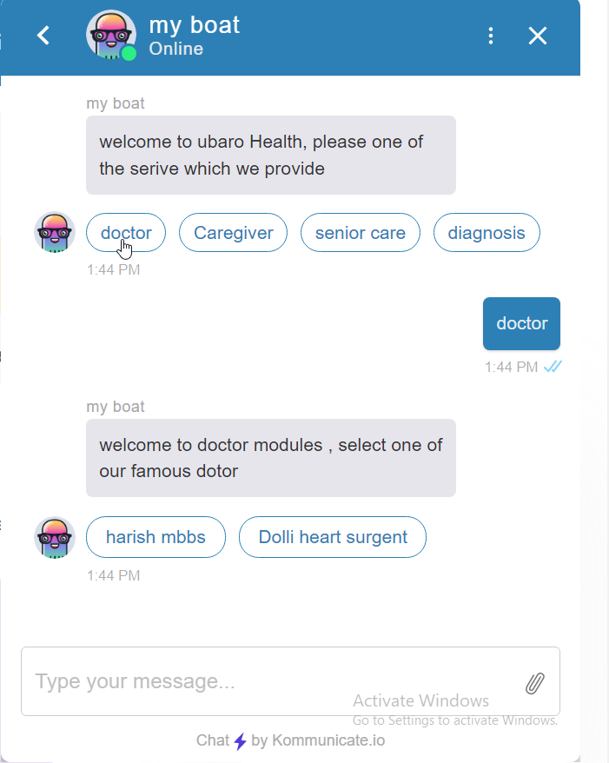

*These is the output*

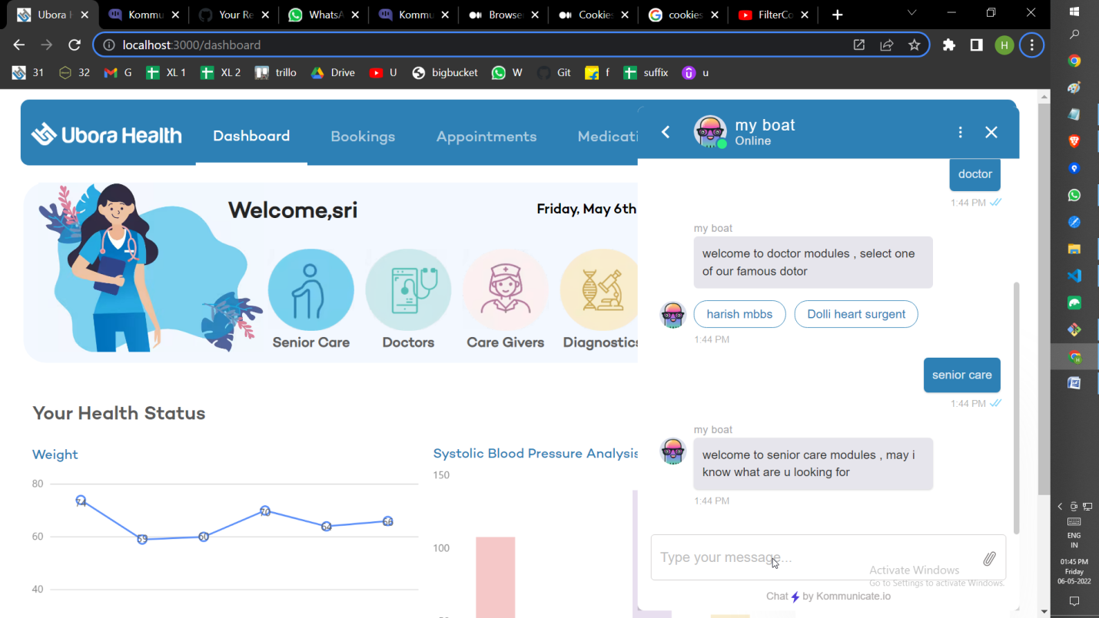

*These is the output,*

*NOTE: till now all the request are handled by the robot only , suppose if user enter a text which robo doesn’t understand, then robo will hand over the chart to the customer   
as show in the below photo , all these we can achieve by config in setting, just explore it*

